**Topics Covered in thisd document :  
1) Eigen Vaues Eigen vectors :**

**2) Hadamard Product**

**3) What is Intuition**

**4) Field and subfield in vector space**

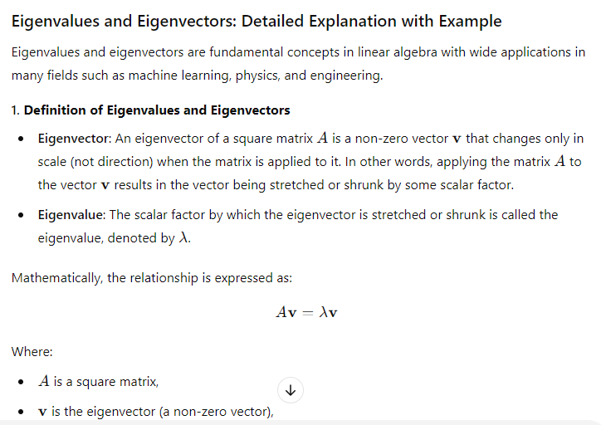

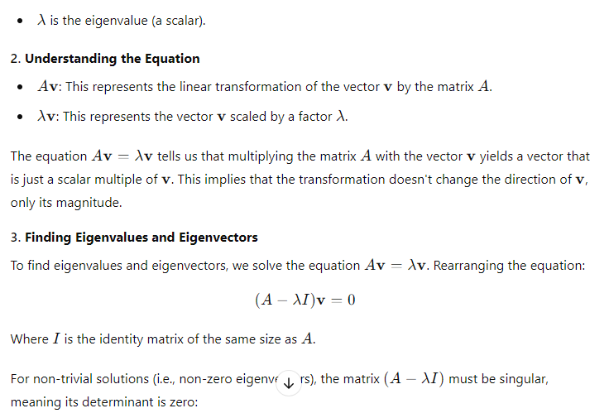

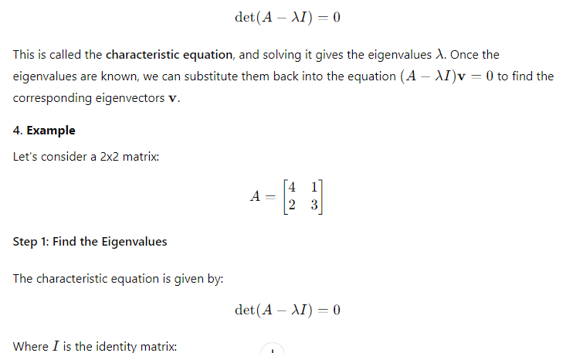

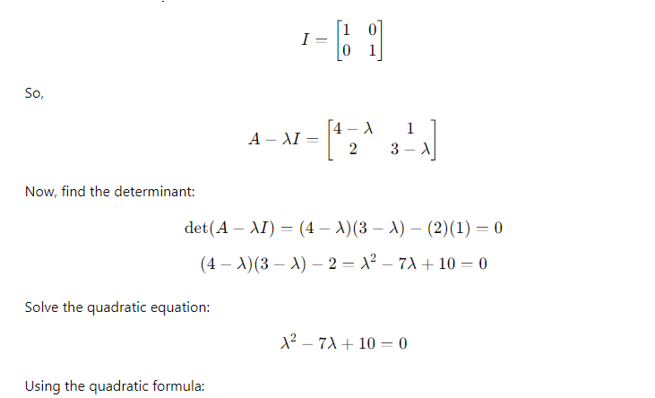

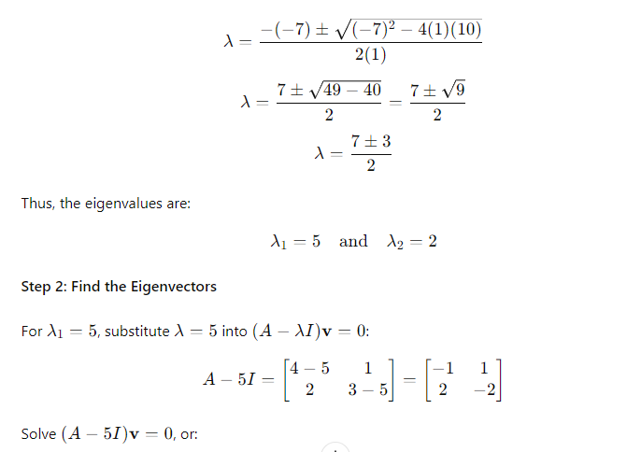

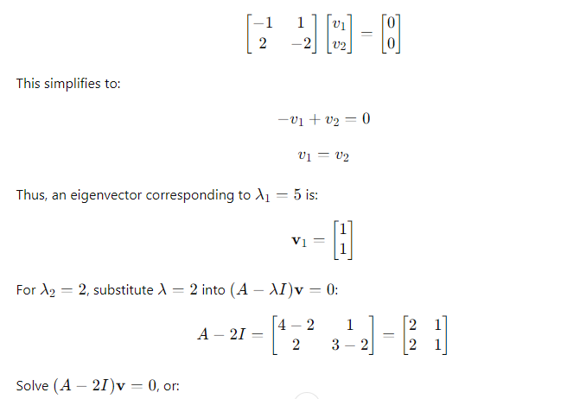

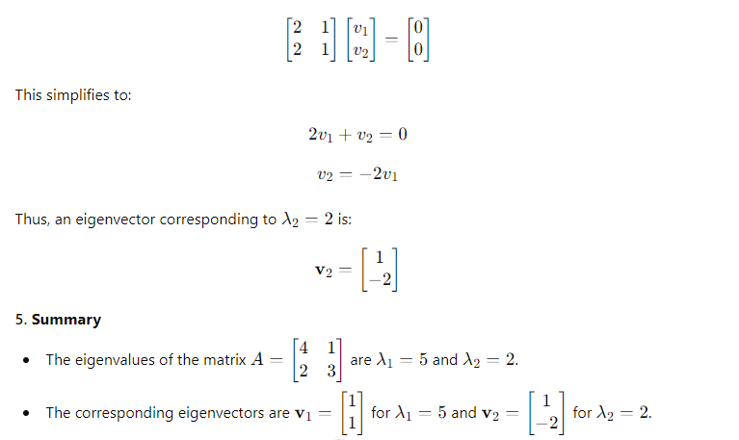

Eigenvalues and eigenvectors give insight into how matrices (which represent linear transformations) stretch and rotate space. These concepts are used extensively in fields like machine learning (e.g., Principal Component Analysis), quantum mechanics, and systems of differential equations.

**Hadamard Product: Detailed Explanation with Example**

The **Hadamard product** (also known as the **element-wise product** or **Schur product**) is an operation between two matrices of the same dimensions, where each element of one matrix is multiplied by the corresponding element of the other matrix. Unlike matrix multiplication, the Hadamard product does not involve sums of products across rows and columns; instead, it simply multiplies elements at the same position in the two matrices.

**1. Definition of Hadamard Product**

For two matrices AAA and BBB of the same size, say m×nm \times nm×n, their Hadamard product is a matrix CCC where each element cijc_{ij}cij​ is the product of the corresponding elements aija_{ij}aij​ from matrix AAA and bijb_{ij}bij​ from matrix BBB.

Mathematically, the Hadamard product is defined as:

C=A∘BC = A \circ BC=A∘B

Where the elements of CCC are given by:

cij=aij×bijc_{ij} = a_{ij} \times b_{ij}cij​=aij​×bij​

for each i,ji, ji,j in the matrices.

**2. Key Properties**

* **Element-wise operation**: Unlike matrix multiplication, there is no summation or row-column interaction. The operation is purely element-by-element.
* **Commutative**: A∘B=B∘AA \circ B = B \circ AA∘B=B∘A (order doesn’t matter).
* **Associative**: (A∘B)∘C=A∘(B∘C)(A \circ B) \circ C = A \circ (B \circ C)(A∘B)∘C=A∘(B∘C).
* **Distributive over addition**: A∘(B+C)=(A∘B)+(A∘C)A \circ (B + C) = (A \circ B) + (A \circ C)A∘(B+C)=(A∘B)+(A∘C).

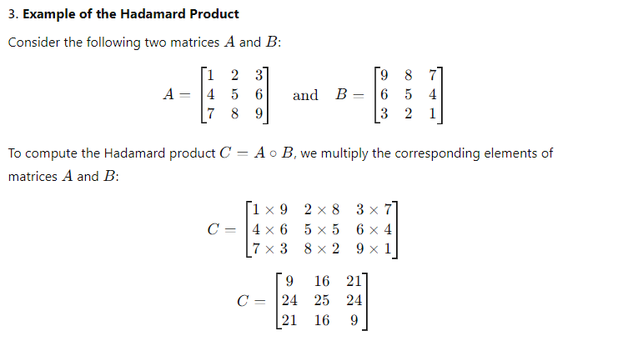

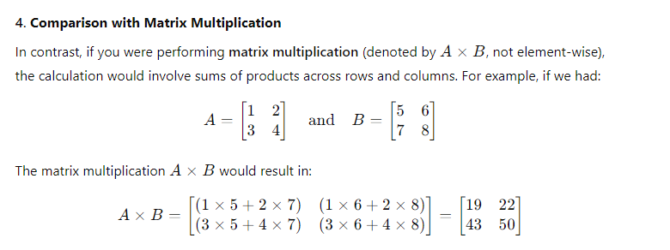

Notice that matrix multiplication involves combining rows of AAA with columns of BBB, whereas the Hadamard product is much simpler and involves no such summation. It's just an element-wise multiplication.

**5. Applications of the Hadamard Product**

The Hadamard product is useful in various fields, such as:

* **Machine Learning and Neural Networks**: The Hadamard product is often used in element-wise operations within the layers of neural networks, particularly when updating weights and applying activation functions.
* **Signal Processing**: In some image and signal processing tasks, element-wise operations are needed, making the Hadamard product suitable for such applications.
* **Statistics and Data Analysis**: When working with element-wise variances, correlations, or transformations on datasets, the Hadamard product becomes a natural operation.

**6. Summary**

* The Hadamard product A∘BA \circ BA∘B is an element-wise product of two matrices AAA and BBB of the same dimensions.
* It differs from regular matrix multiplication by not involving summations and only performing direct element-wise multiplication.
* The resulting matrix has the same dimensions as the original matrices.

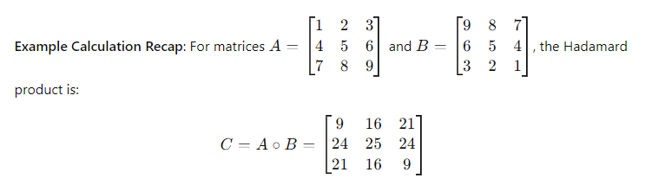

**Intuition: Detailed Explanation with Basics and Examples**

**1. What is Intuition?**

**Intuition** is the ability to understand or know something immediately, without the need for conscious reasoning or evidence. It is often described as a "gut feeling," a hunch, or an automatic judgment that seems to come from nowhere. Unlike logical reasoning, intuition does not require step-by-step analysis; instead, it emerges from past experiences, unconscious pattern recognition, and deep-seated knowledge.

**2. How Intuition Works: A Cognitive Shortcut**

Intuition is a cognitive shortcut that helps the brain make fast decisions in complex or uncertain situations. Here’s how intuition typically works:

* **Pattern Recognition**: Our brains store a vast amount of information from past experiences. Even if we are not consciously aware of it, our brain continuously picks up patterns in this information. When we encounter a new situation, our brain automatically compares it to past experiences and recognizes familiar patterns.
* **Unconscious Processing**: Intuition operates at a subconscious level. We are not always aware of the connections our brain is making between past and present information. This can give us the sense that the solution or insight came "out of nowhere."
* **Emotional Signals**: Intuition is often linked to emotional responses. When the brain processes patterns subconsciously, it might trigger emotional signals, such as a feeling of excitement, fear, or unease, that guide our decisions.

**3. Intuition vs. Logic**

* **Logical thinking** is slow, deliberate, and requires careful analysis of the facts. It involves a step-by-step process, often using rules, data, or calculations to arrive at a conclusion.
* **Intuition** is fast, automatic, and often based on past experiences. It doesn’t require a conscious understanding of why a particular decision is made; you just "feel" that it’s the right or wrong choice.

While intuition is often contrasted with logic, they are not opposites. In fact, intuition is frequently based on accumulated experience and knowledge, even if it’s processed subconsciously.

**4. Examples of Intuition in Everyday Life**

* **Driving a Car**: When experienced drivers are on the road, they don’t consciously think about every single action they take (such as checking mirrors, adjusting speed, or reacting to other drivers). Their intuition guides them, based on years of driving experience. If a car suddenly swerves in front of them, they may instinctively react without consciously thinking through every step. Their brain is recognizing patterns and responding automatically.
* **Reading Emotions**: When you meet someone, you may immediately feel that they are upset or happy even before they say anything. This intuition might come from subtle cues like facial expressions, body language, or tone of voice that you’ve unconsciously picked up and learned from interacting with people in the past.
* **Chess Players**: Professional chess players rely heavily on intuition. While a beginner might have to calculate every possible move and consequence, an expert can often make strong moves based on an immediate feeling of what "looks right." This is because they have encountered similar situations so many times that their brain has developed an intuitive sense of what will work.

**5. Types of Intuition**

1. **Expert Intuition**: This comes from deep knowledge or experience in a specific field. For example, a doctor might make an intuitive diagnosis after seeing similar symptoms countless times. This kind of intuition is very reliable because it’s based on expertise.
2. **Creative Intuition**: This type of intuition often leads to breakthroughs in art, science, and innovation. It happens when ideas "click" unexpectedly, often after a period of deep thought or problem-solving. For example, Albert Einstein’s theory of relativity was partly inspired by an intuitive "thought experiment" about riding a beam of light.
3. **Social Intuition**: This helps people navigate social situations and understand others’ emotions, motivations, or intentions. It’s often seen in people with high emotional intelligence, who can "read the room" and respond appropriately without needing to analyze every interaction.
4. **Moral Intuition**: This is the immediate sense of right or wrong that we often feel in ethical situations. For example, when you see someone being treated unfairly, you may have an immediate sense that it is wrong, even if you haven’t thought through the ethical principles involved.

**6. Strengths and Weaknesses of Intuition**

**Strengths:**

* **Speed**: Intuition allows for fast decision-making, which can be critical in time-sensitive situations, such as during emergencies.
* **Efficiency**: It helps to filter out unnecessary information, focusing on the most relevant factors.
* **Experience-Based**: Intuition leverages experience and knowledge, allowing experts to make decisions without needing to analyze every detail.

**Weaknesses:**

* **Biases**: Intuition can be influenced by cognitive biases (e.g., confirmation bias, availability bias), which can lead to inaccurate judgments.
* **Limited by Experience**: Intuition is only as good as the experience and knowledge behind it. If someone has little experience in a particular area, their intuition may be less reliable.
* **Overconfidence**: Relying too much on intuition can make people overconfident, leading them to ignore important facts or logical reasoning.

**7. Improving Intuition**

While intuition can feel like a natural gift, it can also be developed and honed:

1. **Experience**: The more experience you have in a particular field, the better your intuition becomes. For example, seasoned investors may develop a "feel" for when to buy or sell stocks because they have years of experience observing the market.
2. **Reflection**: Take time to reflect on past decisions and outcomes. This helps your brain learn from patterns and mistakes, sharpening your intuition over time.
3. **Learn from Others**: By studying how experts make decisions in a particular area, you can adopt their thought processes and develop your own intuitive understanding.
4. **Mindfulness**: Practicing mindfulness and being present in the moment can help you tune in to your intuitive feelings and recognize when they arise.

**8. Example of Intuition in Decision-Making**

Imagine you are a manager hiring someone for a job. You have two candidates who both have impressive resumes and did well in interviews. One candidate, however, just gives you a better "gut feeling" during the interview. Something about their demeanor, confidence, and answers feels right, though you can’t explain exactly why.

This gut feeling is your intuition at work. It’s likely based on your past experiences interviewing other candidates, even though you might not consciously realize it. If you’ve been hiring for years, your brain has picked up on patterns of what makes a successful candidate, and it is using that past information to guide your decision.

You might choose to trust your intuition in this case, but you could also double-check it by reviewing the candidates’ qualifications or getting a second opinion. This shows how intuition can work in conjunction with logical reasoning.

**9. Conclusion**

Intuition is a powerful and often necessary tool for making decisions, especially when time is limited, or when logical analysis is impractical. However, it’s important to recognize its limitations and combine it with critical thinking when appropriate. While intuition can be sharpened through experience and mindfulness, it is still important to remain aware of potential biases or overconfidence that can lead to errors in judgment.

In summary:

* **Intuition** is fast, experience-based, and subconscious.
* **Logical thinking** is slow, deliberate, and conscious.
* The best decision-makers often balance intuition with logic, using both to arrive at the best outcome.

**4 ) Field in Vector Space**

A **field** in the context of vector spaces is a set of numbers (scalars) over which the vectors are defined. The field provides the values used for scalar multiplication in the vector space. Common examples of fields include the set of real numbers R\mathbb{R}R and the set of complex numbers C\mathbb{C}C.

**Example:**

* **Field of Real Numbers** R\mathbb{R}R: A vector space over R\mathbb{R}R means that the scalars used to multiply vectors are real numbers.
* **Field of Complex Numbers** C\mathbb{C}C: A vector space over C\mathbb{C}C uses complex numbers as scalars.

**Subfield**

A **subfield** is a subset of a field that is itself a field under the same operations (addition and multiplication). For example, the rational numbers Q\mathbb{Q}Q form a subfield of the real numbers R\mathbb{R}R, because Q\mathbb{Q}Q contains numbers that follow the same addition and multiplication rules as R\mathbb{R}R.

**Example:**

* **Field**: R\mathbb{R}R (Real numbers)
* **Subfield**: Q\mathbb{Q}Q (Rational numbers) In a vector space over R\mathbb{R}R, you could also define a subfield over Q\mathbb{Q}Q, meaning the scalar operations can be restricted to rational numbers only.

**Summary:**

* A **field** is the set of scalars used in a vector space (e.g., real numbers or complex numbers).
* A **subfield** is a smaller field within a larger field, following the same operations (e.g., rational numbers are a subfield of real numbers).